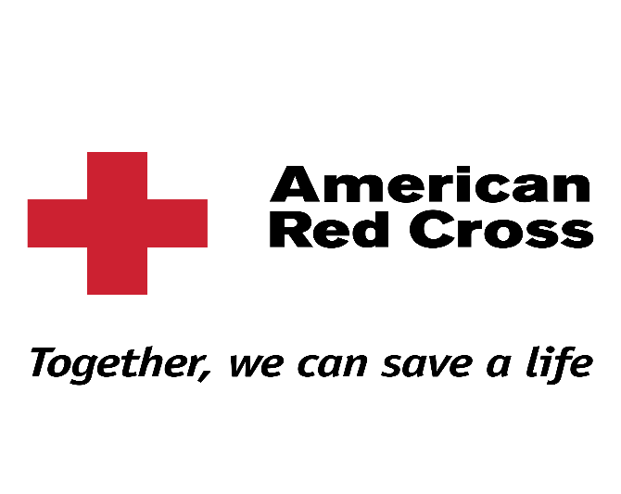
BLENDED LEARNING COURSE INSTRUCTIONS
Allow a minimum of 2 hours to complete the online missions prior to attending your live/classroom training
Please use Google Chrome as your web browser to access the online portion of your course. For accuracy cut and paste this link directly in the web browser.
http://www.redcrosslearning.com/course/301040f0-c611-11e6-981d-bb8e5751112f
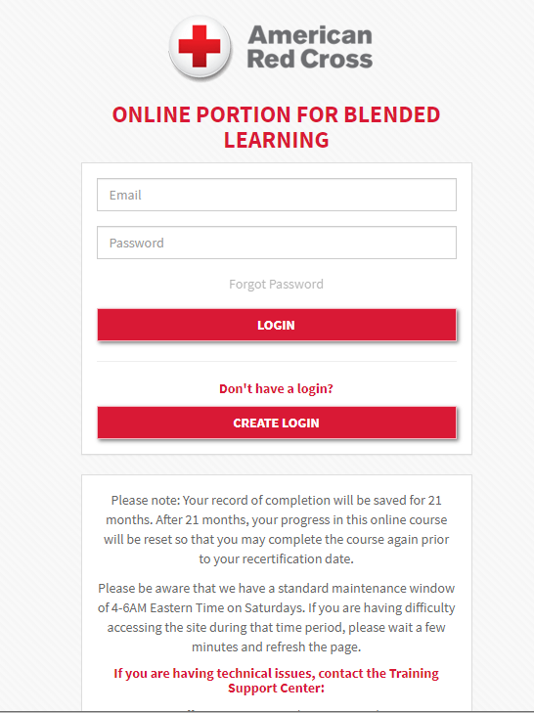
Create a Login

